Change your mind. Change your life.

Tillamook Bay Community College does not discriminate on the basis of race, color, national origin, disability, sex, age, religion, height/weight ratio, marital status, gender, gender identity, sexual orientation, organizational affiliation, political affiliation, or protected veterans’ status with regard to employment, admissions, access to education programs, or activities as set forth in compliance with federal and state statutes and regulations.

Student Handbook
2022-2023 Academic Year

2022-2023 Important Dates
(Dates are subject to change. Please look at the current term’s class schedule for the most recent calendar.)
2022
MAY 23 Summer and Fall Term Registration Begins
JUNE 18 Spring Term Ends
JUNE 27 Summer Term Classes Begin
JUNE 30 Last Day to Drop or Audit a Course
JULY 4 Independence Day – College Closed
AUGUST 7 Last Day to Withdraw or Change Grade Option
AUGUST 18 Fall Registration Opens
SEPTEMBER 3 Summer Term Ends
SEPTEMBER 5 Labor Day – College Closed
SEPTEMBER 14 - 16 College In-service – College Closed
SEPTEMBER 19 Fall Term Classes Begin
SEPTEMBER 23 Last Day to Drop or Audit a Course
NOVEMBER 11 Veterans Day – College Closed
NOVEMBER 11 Last Day to Withdraw or Change Grade Option
NOVEMBER 21 Winter Term Registration Begins
NOVEMBER 24 - 25 Thanksgiving Day – College Closed
NOV 28 – DEC 2 Fall Term Finals Week
DECEMBER 3 Fall Term Ends
DECEMBER 19 –23 Winter Holidays/College Closed

2022
JANUARY 2………………………………………………………… Winter Holidays/College Closed
JANUARY 9 Winter Term Classes Begin
JANUARY 13 Last Day to Drop or Audit a Course
JANUARY 16 Martin Luther King, Jr. Day – College Closed
MARCH 3 Last Day to Withdraw or Change Grade Option
FEBRUARY 27 Spring Term Registration Begins
MARCH 13 - 17 Winter Term Finals Week
MARCH 18 Winter Term Ends
MARCH 27 - 31 Spring Break
APRIL 3 Spring Term Classes Begin
APRIL 7 Last Day to Drop or Audit a Course
MAY 20 Summer and Fall Term Registration Begins
MAY 26 Last Day to Withdraw or Change Grade Option MAY 29 Memorial Day – College Closed
JUNE 12 -16 Spring Term Finals Week
JUNE 16 Commencement Exercises
JUNE 17 Spring Term Ends

Welcome

Tillamook Bay Community college provides access to quality education in response to the needs of our community. Our president, Dr. Ross Tomlin notes:
The faculty and staff all have a strong passion for helping students succeed and will work tirelessly to make sure you have all the information you need to make the best decisions on your classes and career choices. The college has a values statement that says, “Tillamook Bay Community College values and promotes student success through academic excellence and resourceful teamwork in an environment that is personal and friendly.” We take this statement to heart in everything we do for students.

The advising staff at TBCC wants students to take a proactive approach to their education. While we are here to help, we also want students to take ownership of their degree plan. Some of the things that students can do to accomplish this include:
- Review your degree plan after each term
- Be involved in the advising process by preparing for meetings
- Consider ideas from advisors, faculty, and other mentors
- Actively pursue an educational plan directed toward completion of a degree or certificate at TBCC
Which of these areas do you wish to study/complete a degree in and/or ultimately work in?
I want to study literature, poetry, art, writing, or a foreign language
I want to work with numbers and financial information, in a business setting, running a business, managing people and/or marketing.

I want to work in manufacturing, industrial or mechanical systems, welding and/or electrical fields using my hands.

I want to work in the healthcare field or in a hospital (e.g. Medical Assisting, Emergency Services, Nursing, Phlebotomy, etc.)

If you want to work with animals, crops, plants, farms, or trees in the great outdoors

I want to think critically and logically studying science, math, and computer programs.

I want to care for others, solve problems, work in a team, and help people improve their lives

As a student, you will need two publications to start planning your future at Tillamook Bay Community College: the TBCC College Catalog and the Schedule of Classes.

The Schedule of Classes is designed to help you register for courses at Tillamook Bay Community College. The Course Schedule is published four times a year (fall, winter, spring, and summer terms). The schedule of classes is available online at www.tillamookbaycc.edu and clicking on the current term’s Course Schedule. Paper versions of the schedule are mailed to every mailbox in Tillamook County. They are also available on campus and in the Tillamook County Library.

Important Information about TBCC is printed in the Schedule of Classes:

- Tuition and Fees
- How to Pay
- Available Student Services
- Final Exam Schedule
- Student Disclosure Statement
- Academic Calendar
- Add/Drop Timetable
- Withdrawal Policy
- How to Register
- Student Records
- Accommodations for Students with Disabilities

The College Catalog has full course and program descriptions as well as transfer, graduation, and certificate requirements. Student Rights and Responsibilities are stated, including a section regarding the grievance process. The catalog is
published annually and is available on the website www.tillamookbaycc.edu or at the main campus

Planning Your Class Schedule
Most classes run for 11 weeks. Always check the beginning and ending dates of your classes in the quarterly schedule of classes and on your registration schedule. When planning your class schedule consider the following guidelines.

- Generally, each course credit requires one hour of class time per week. For example, a four-credit class usually means that you will be in class four hours each week. Classes with labs often require more than one hour per week per credit earned.
Part Time & Full Time Enrollment Status
¼ Time = 3 – 5 credits per term
½ Time = 6 – 8 credits per term
¾ Time = 9 – 11 credits per term
Full Time = 12 or more credits per term

- For each hour you spend in class, plan to spend at least two hours in study time. Be sure to calculate study time when considering how many classes you take each term.

- In addition to class and study time, consider your family, work commitments, and time for yourself. Many TBCC students are employed either full-time or part-time; however, they find a way to balance it all with careful planning.

Here are some general guidelines about work and school commitments:
If you work: | Consider Taking:
40 hours per week | 6-8 credits
30 hours per week | 9-10 credits
20 hours per week | 12 credits
5-15 hours per week | 12-15 credits

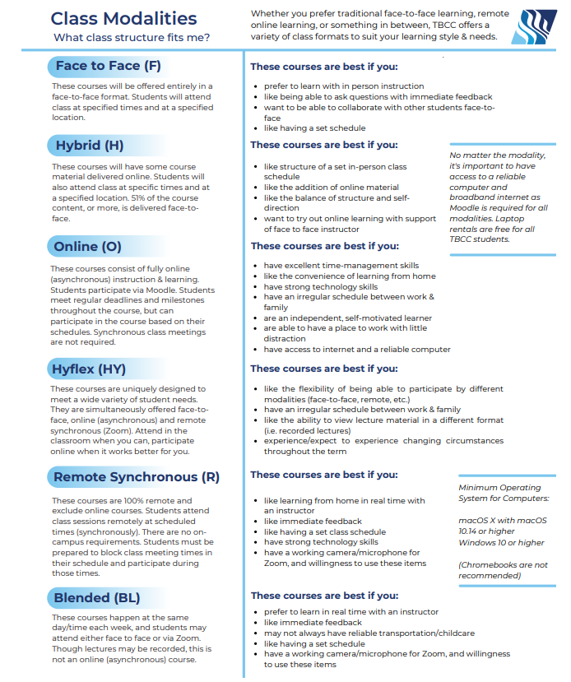
Enrollment
- Enrollment in online courses is limited to residents of Oregon, Washington, and Idaho. All online courses are taught through the Canvas online platform. Once you register for an online class, you can familiarize yourself with Canvas at www.tillamookbaycc.edu
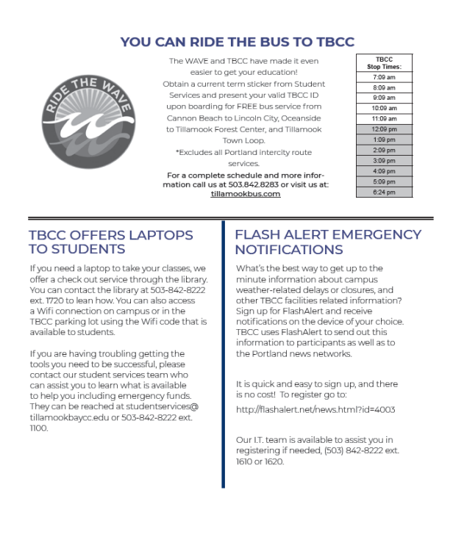

Campus Life – Student Groups

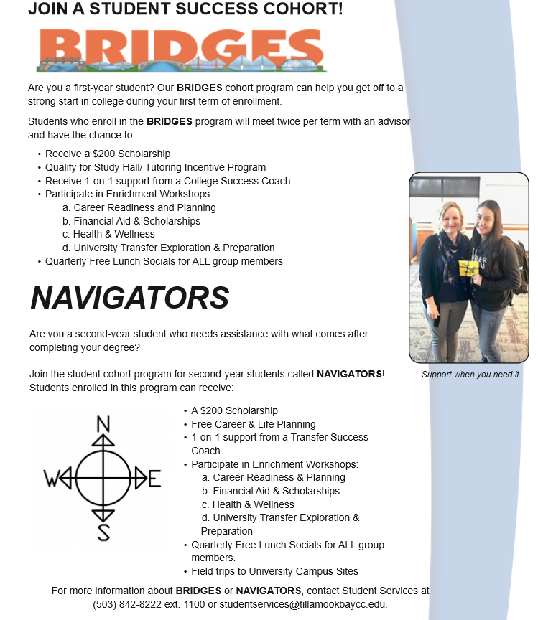

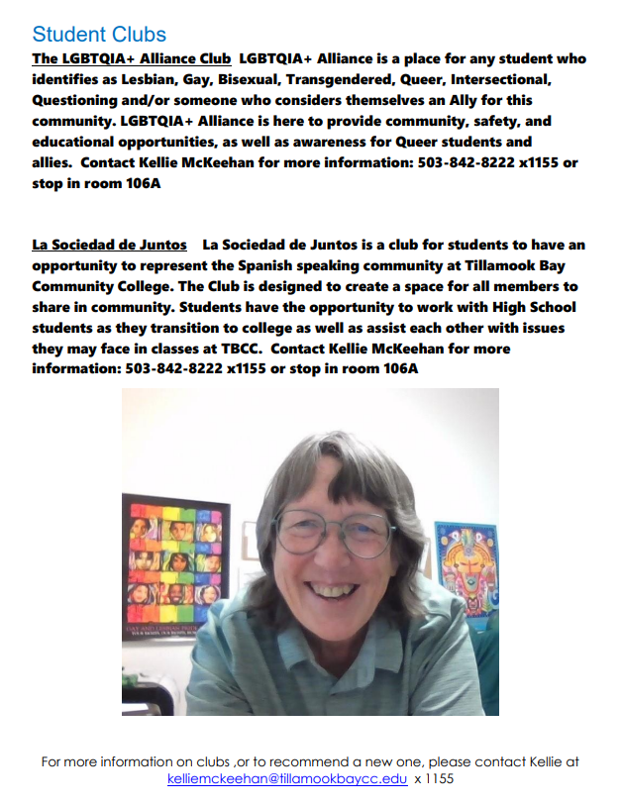

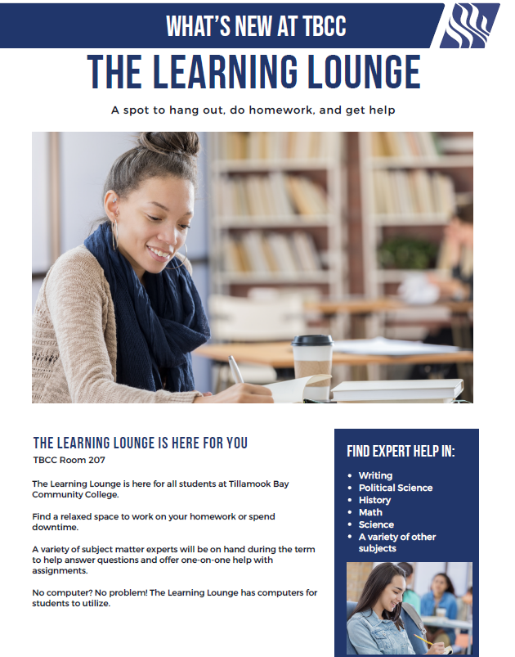

MyTBCC Account

MyTBCC can be accessed by any active TBCC student anywhere the internet is available. To log on go to www.tillamookbaycc.edu, and then click on the MyTBCC tab.
- In the user ID box type your student ID number.
  - Your student ID number is emailed to you when your initial admission is processed. It can be found on your TBCC ID card.
- To set your password:
  - Click on “I forgot my password”.
  - On the next page, enter your TBCC student email address. If you don’t have access to your student email, check with our IT department for help setting it up.
  - You will receive a link in your student email to set your password.
- Once you have entered your user ID and password click login.

Financial Aid
Many types of financial assistance may be available to you as a TBCC student including:
Grants – Do not have to be paid back.
- Federal Pell Grant
- Federal Supplemental Educational Opportunity Grant (SEOG)
- Oregon Opportunity Grant
Oregon Promise Grant– Does not have to be paid back.
- Must be a Oregon High School graduate/GED completer
- Oregon resident for one consecutive year or more
- Must maintain a 2.0 GPA or higher
- Must commence attendance at an Oregon community college within six months of high school or GED completion
Loans – Must be paid back with interest.
- Federal Subsidized Stafford Loan
- Federal Unsubsidized Stafford Loan
Student Employment – Work Study
- Student earns amount awarded
- Must be selected (hired) for work study position
- Works designated hours per arrangement with position supervisor
- Earns monthly paycheck for hours worked.
Steps to apply for Financial Aid
- Complete the FAFSA at fafsa.ed.gov or complete the ORSAA for non-eligible residents at oregonstudentaid.gov. Be sure to use the TBCC school code 041949.
- Monitor your TBCC email account and respond promptly to requests for additional information.
- Accept your FA offer on-line through our Financial Aid Tracker
For more information, check out the Paying for College page on the TBCC website at www.tillamookbaycc.edu.
You may also come to Student Services, email, or call to ask financial aid questions. Your Financial Aid Advisors are Sally Jackson or Beth McBride.
Email | Phone
SallyJackson@tillamookbaycc.edu  BethMcbride@tillamookbaycc.edu | 503-842-8222 ext. 1130  503-842-8222 ext.1135

Maintaining Academic Success at TBCC

Stay in Class – Get Good Grades

Satisfactory Academic Progress (SAP)

Good Standing Status:
- Maintain a cumulative grade point average of a 2.0 or higher
- Successfully complete two-thirds of attempted credits each term
- Maintain the ability to complete your declared degree or certification within 150% maximum time frame limit (to remain Financial Aid Eligible)

Warning Status:
A student in SAP Warning status will still be able to register for class and receive aid the following term.
- Student’s cumulative GPA has dropped below 2.0
- Student did not complete two-thirds of all attempted credits in a term
- Student is unable to graduate within 150% of maximum time frame limit (no longer Financial Aid Eligible).
Suspension Status:
- Student did not meet SAP standards while in Warning Status
- It is determined that the student will not be able to graduate within 150% maximum time frame limit
- Student assigned to a required Financial Aid Academic Plan fails to follow the plan (Not Eligible to Receive Financial Aid)
Appeal of a Suspension
A student on Academic Suspension must appeal in order to register. The student will create a Learning Contract with a Career Education Advisor before they may be eligible to register for classes or receive financial aid.
Contact Student Services as soon as possible to resolve any Satisfactory Academic Progress concerns or questions at StudentServices@TillamookBayCC.edu or 503-842-8222 x 1100.

Attendance and Withdrawal Policies
Class Attendance
Yes, you need to attend all classes in which you are enrolled. If you do not attend the first week you may be dropped from the course as a no-show. Attending all of your classes will help you be more successful in achieving your goals. If a student does not attend classes, complete coursework, or withdraw from the class in a timely manner could result in a failing grade.
Do I get my money back if I drop a class?
Yes, if you've made a payment and you drop by the first Friday of the Term. Please refer to the chart below for deadlines. All charges associated with a class will be removed from your account balance if you officially drop by the deadline listed in the matrix below.
No charges will be removed if you drop after the deadline. For questions, contact the Business Office at 503-842-8222 ext. 1210.
Deadlines to DROP a class:
Length of Class | Deadline to Drop (and not have W on transcript and get full refund)
8-11 weeks | By the end of the first week of classes. May drop Online or In person at Student Services.  - Monday, Thursday: 7:30 am-4:30 pm  - Tuesday and Wednesday: 7:30 am – 7:00 pm  - Friday: 8:30 am to 4:30 pm
2-7 weeks | By the end of the first day of classes.
Less than 2 weeks | Before the first day the class meets.

Deadlines to WITHDRAW from a class:
Length of Class | Deadline to Withdraw (“W” grade goes on transcript, GPA is not affected, and no refund)
11-12 weeks | By the eighth Friday of the term.
8-10 weeks | In the first 80% of class meetings.
2-7 weeks | In the first 80% of class meetings.
Less than 2 weeks | Before the first day class meets.
Notes: After the Withdrawal period, a grade must be assigned for the course.

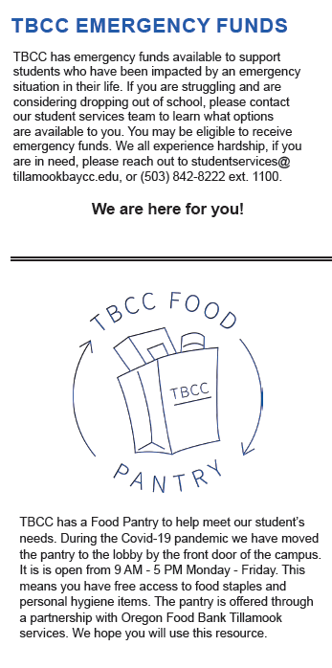
\ 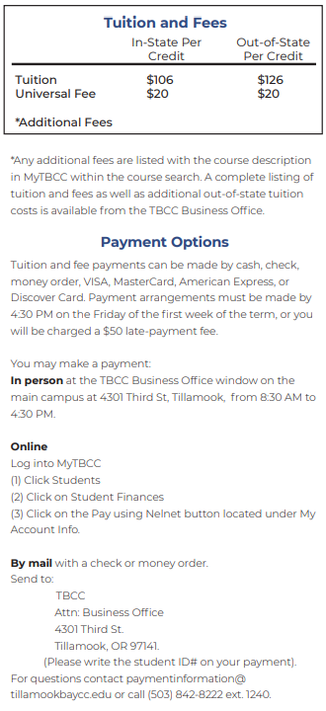

Online Bookstore - Online Bookstore and Open Educational Resources (OER’s) At Tillamook Bay Community College, we want to make sure you continuously receive the best in education. To help us deliver on this goal, we work closely with our textbook partner, MBS Direct, to guarantee that you and all students have the correct course materials. MBS Direct was carefully selected to deliver the best value for you and to ensure peace of mind because course materials are specific to your class schedule, with no hidden costs.
Students may use their approved TBCC financial aid to purchase or rent books online through the online bookstore.
Community Resources
Resources for issues involving alcohol and drugs are available in the information area in the TBCC lobby. Reach Alcoholics Anonymous for Tillamook at 503-842-8958 and North Coast Area Narcotics Anonymous at 503-801-9924.
Alcohol and Drug
Counseling

CARE Emergency and Homeless Services Program at 2310 First St Ste. 2, Tillamook, OR 97141, or contact them by phone at 503-842-5261.

Up-to-date career and job market information is available through the CIS program (Career Information System) available at TBCC. For additional career resources and help with your job search, visit the TBCC website and click on “Get Started”.
Career Resources
Community Quality, affordable, and accessible health services. No one is turned
Health Center away for inability to pay. Locations in North, Central, and South County. Contact them at 503-842-3900 or 800-528-2938. 801 Pacific Ave, Tillamook, OR 97141 or visit tillamookchc.org for more information.
In order for a TBCC student to receive their free Bus Pass per term, you must take your schedule and Student ID to the TBCC Library. For more information on routes and times visit http://www.nworegontransit.org.
Bus Pass
If you are in need of Veterans Services, you may call 503-377-0294 (local) or The Oregon Department of Veteran’s Affairs 1-800-692-9666. (Vets seeking information about education-related issues should contact Sally Jackson at 503-842-8222 ext. 1130.)
Veterans Services

Serves all individuals who have experienced domestic violence, rape, and sexual assault. Help is available for all genders, ethnicities, and sexual orientations. Contact them at 1902 2nd St., Tillamook, and at 503-842-9486 or 800-992-1679.
TIDES OF CHANGE

Smokeless/Tobacco-Free Environment
TBCC is committed to providing a safe and healthy environment for its employees, students, and visitors. In light of the findings of the U.S. Surgeon General that exposure to second-hand tobacco smoke and use of tobacco are significant health hazards, Tillamook Bay Community College has established smokeless and tobacco-free environment. Consequently, use, distribution, or sale of tobacco, e-cigarettes, any smoking device, or carrying of any lighted smoking instrument, on college premises is prohibited.

Glossary for navigating TBCC:
MyTBCC – Where you will find your student record and add/drop classes.
Canvas – Online Class Platform where you will find your assignments and submit them
TBCC Email – How TBCC staff and faculty will contact you.
Change Class Schedule – MYTBCC>>Students>>Add/Drop
You can drop classes yourself through the Friday before term starts. After that, you must speak to your advisor and fill out an Add/Drop form.
Withdraw from a class – Contact your Financial Aid Advisor
A student can withdraw from a class up until February 26. You will need instructor approval A “W” will appear on your transcript but it will not affect your GPA.
Emergency Funds— >>MYTBCC>>Students
Life Happens, if you find yourself in a situation where you unexpectedly need funding to keep you in classes. Fill out Emergency Fund Application online.
STEP— Funding for short-term certificates Contact Jenny Case
Student Clubs—>>MYTBCC>>Campus Life—Contact Kellie McKeehan for more information
Office or Office 365—>>Log in to Email>>
Use cloud-based programs or click “Install Office” to add onto up to two devices
Check your balance—>>MYTBCC>>Quick Links>>Payment Information
Find your schedule—>>MYTBCC>> Courses
Find/Order your books—>>MYTBCC>>Quick Links>>Online Bookstore
OERS (Online Educational Resources)—>>MYTBCC>>Quick Links>>OER Information
Download a digital copy of your textbook as a PDF or order a printed version from the TBCC Library for the listed fee.
Directory – tillamookbaycc.edu>>Directory
contact information for TBCC staff, and faculty

Student Concerns
It is the policy of Tillamook Bay Community College and its Board that there will be no discrimination or harassment on the grounds of race, color, sex, marital status, sexual orientation, religion, national origin, age, disability height/weight ratio, organizational affiliation, or political affiliation in any educational programs, activities or employment. Lack of English language skills will not be a barrier to admission and participation in career and technical education programs. Persons having questions should contact the appropriate person listed below.
For assistance, support, or help in obtaining information about complaint procedures and resolving problems, please contact the following:
• Accessibility Services: Student Services
(503) 842-8222, ext. 1100.
• Sexual Harassment: Rhoda Hanson, Associate Vice President (AVP) of Student Services
(503) 842-8222, ext. 1110.
• Harassment based on race/ethnicity/national origin:
Pat Ryan, Facilities and Safety
(503) 842-8222, ext.1020.
• Students’ rights, responsibilities, and conduct: Rhoda Hanson, AVP of Student Services
(503) 842-8222, ext. 1110.
• Academic grievances: Paul Jarrell, Vice President of Instruction & Student Services
(503) 842-8222, ext. 1030.
• Other harassment: Rhoda Hanson, AVP of Student Services
(503) 842-8222, ext. 1110.

Students can directly access detailed information about the student grievance procedures in the general catalog on the College website http:// www.tillamookbaycc.edu/catalog.

TBCC GRIEVANCE PROCEDURE
Tillamook Bay Community College Grievance Procedure
A. Introduction
Students enrolled at Tillamook Bay Community College may use the Grievance Procedure to challenge decisions and/or actions taken by college faculty and staff that are alleged to violate their rights as defined in the College Catalog. Any other complaint about College services, programs, or activities not addressed in the College Catalog or Policy should be put in writing and sent to the Director/Officer designated in the chart above.
Programs based on contracts with government agencies or external funding sources may adopt separate grievance procedures consistent with Tillamook Bay Community College’s Grievance Procedure, the program’s goals, and the principle of due process for all parties.
The student will be allowed to have an advocate of his/her choice (such as a Tillamook Bay Community College Advisor, or student government representative) present in meetings throughout the grievance process. Advocates are not permitted to present the case, but may advise the student. Both the College and the student may seek legal advice at their own expense; however, neither the College nor the student shall be represented by a lawyer during any grievance meeting or hearing involving the College and the student.
Concerns involving harassment or discrimination by a College staff member on the basis of race, color, religion, sex, sexual orientation, age, national origin, disability, or veteran status should be directed to the College’s Affirmative Action Officer. Concerns involving harassment or discrimination by a student on the basis of race, color, religion, sex, sexual orientation, age, national origin, disability, or veteran status should be directed to the Director of Student Services.
B. Grievance Procedure
Step 1: Communicate with the Faculty/Staff Member:
a. The student is encouraged to communicate with the faculty/staff member involved. They may communicate with any person with whom they feel most comfortable, based upon level of trust and relationship. The person may become their advocate. The advocate can support, though not communicate for, the student throughout the process. The issue must be brought to the initial review (see chart) within 30 calendar days of the event that is the subject of the grievance/complaint. Otherwise, the student forfeits the right to grieve the issue. The student is encouraged to put the grievance in writing, including a specific description of the problem, the reasons the student believes his/her rights have been violated as defined in the College Catalog, and a proposed remedy.
Step 2: VP of Instruction and Student Services or AVP of Student Services
a. In cases where the problem is not resolved through direct communication with the faculty/staff member involved, the student will submit a Grievance Form obtained from the VPISS or the AVP of Student Services with supporting evidence, to the VPISS or AVPSS within 14 calendar days of the communication with the faculty/staff member. The VPISS or AVPSS will review the grievance.
b. Within 14 calendar days, the VPISS or AVPSS will objectively investigate the grievance, consult and share appropriate information with all involved parties, consider relevant evidence, and render a decision in writing to the student and the College President.
Step 3: Appeal to the College President
a. The student may appeal the decision in Step 2 if (1) Tillamook Bay Community College procedures were not followed or (2) there is relevant evidence that was not available during Step 2. An appeal must be made within 14 calendar days to the College President. The student must submit written justification for further review and provide evidence that there are grounds for the appeal.
b. The President will objectively investigate how the grievance process was conducted in Step 2, consult with all involved parties, and consider relevant evidence that was not available or not considered during Step 2, and render a decision in writing within 10 business days of the appeal. The decision will be final and not subject to appeal.
C. Reporting, Recording, and Maintaining Records
When the grievance is concluded, all documentation shall be forwarded to the AVP of Student Services, who will maintain them as part of student records in accordance with the state archival policies.

Student Rights and Responsibilities
Tillamook Bay Community College provides students with programs of general education, developmental/remedial programs, and vocational/technical curricula. The college also provides cultural, recreational, and community service activities. It is, in turn, the responsibility of the student to observe college rules and regulations and to help maintain appropriate conditions in the classroom, on the campus, and in the community.

A. General Policies
A student's registration obligates him/her to comply with the policies and regulations of the college. Tillamook Bay Community College will restrict a student’s admission to, or registration with the college and will withhold degrees, and official transcripts as prescribed by the college and/or state guidelines if a student fails to meet financial obligations to the college or for other legal reasons. Tillamook Bay Community College is granted the right by law to adopt such rules as are deemed necessary to govern its operations. Students have the right to participate in formulating and reviewing policies and rules pertaining to student conduct and, to the extent permitted by law, in the enforcement of all such rules.

B. Right to Freedom from Harassment and Discrimination
The college's goal is to enable students to achieve their education and career goals. Therefore, it is against this policy for any manager, supervisor, faculty, staff, or student to engage in harassment or discrimination of any member of the college community based on his/her race, color, religion, ethnicity, use of native language, national origin, age, sex, marital status, height/weight ratio, disability, or sexual orientation. The prohibition against harassment or discrimination based on the use of native language does not require the college to offer courses in any language other than English. Under this policy, harassing or discriminatory behaviors will not be tolerated. The college also prohibits retaliation against any person who makes a good faith complaint of discrimination of harassment and retaliation against any person who in good faith cooperates in an investigation of alleged harassment or discrimination. Therefore, it is the responsibility of every member of the college community to strictly comply with this policy. This includes notifying each employee/student of his or her rights and responsibilities under Tillamook Bay Community College’s Student Rights and Responsibilities and Sexual Harassment Policies. Management staff will be held accountable for taking reasonable action to maintain work areas and educational environments free of conduct that causes, or reasonably could be considered to cause, intimidation, hostility, or discrimination. Any person who believes he or she has been discriminated against or harassed by a college employee, representative, or student is encouraged to file a complaint with the Director of Facilities, Safety, and Human Resources. Non-affirmative action complaints are to be filed in accordance with the Student Grievance Procedure.

C. Right to Freedom of Expression
Students shall be free to take reasoned exception to the data or views offered in any course of study and to reserve judgment about matters of opinion, but they are responsible for learning the content of any course of study in which they are enrolled. As constituents of the academic community, Tillamook Bay Community College students shall be free, individually and collectively, to express their views on issues of institutional policy and procedures which shall include the examination and discussion of issues of interest to them and expression of opinions both publicly and privately. They shall be free to invite and to hear persons of their choosing and to support causes by orderly means that do not substantially disrupt the regular and essential operations of the college. Demonstrations are a legitimate mode of expression, whether politically motivated or directed against the college administration, and will not be prohibited. Demonstrators, however, have no right to deprive others of the opportunity to speak or be heard, take hostages, physically obstruct the movement of others, or otherwise substantially disrupt educational or institutional processes in a way that interferes with the safety or freedom of others. Students may be subject to disciplinary action when their acts or actions cause or are likely to cause substantial disruption or interference with the regular and essential operation of the college.

D. Right to Protection from Improper Academic Evaluation and Improper Disclosure of
Students’ Views, Beliefs, and Associations
Student academic performance shall be evaluated solely on an academic basis (which may include attendance and the ability to apply skills), not on the student's opinions or conduct in matters unrelated to academic standards. The course syllabus shall contain and articulate the evaluation standards and grading criteria by which student performance is measured. Students shall have the right to grieve their academic evaluation under the Grievance Procedure only if the student believes that these standards and criteria were not followed by the instructor, or were not fairly and consistently applied to all students. At the same time, students are responsible for meeting standards of academic performance established for each course in which they are enrolled. Information about student views, beliefs, and political associations which staff members acquire in the course of their association with students is to be considered confidential.

E. Right of Access to, and Protection from Improper Disclosure of Student Records
To minimize the risk of improper disclosure, academic and disciplinary records shall remain separate. Transcripts of academic records shall contain only information about academic status. Information from disciplinary or advising files shall not be available to unauthorized persons on campus or to individuals off-campus without the written consent of the student involved, except under legal compulsion or in cases where the safety of persons or property is involved, in compliance with the Family Educational Rights and Privacy Act, college policy, and Oregon laws pertaining to education records. In order to assist students to benefit from courses, programs, and activities, the college requires advising services and Career Education Plans for degree-seeking students. The confidentiality of student record information obtained by advising services will be strictly maintained, except when Tillamook Bay Community College is legally permitted to disclose student record information.

F. Right to Form Student Organizations
Students may form student clubs and organizations under the provisions of the Associated Students of Tillamook Bay Community College (ASTBCC) Constitution. Any chartered student club or officially recognized student organization acting through the Associated Students of Tillamook Bay Community College may invite any person of their own choosing to the campus, provided the invitation and arrangements are in compliance with established policies of the college. College procedures must be followed to ensure orderly scheduling of facilities, adequate preparation for the event, and that activities are conducted in a manner appropriate for an academic community.

G. Right to Sell and Distribute Materials and Engage in Fund-Raising Activities
Students have the right to engage in legal incidental sales of personal property in private transactions. TBCC has not designated any facilities for this purpose, however, except for the use of designated college bulletin boards. All fund-raising activities for any student group must be approved by the comptroller and the Executive Director of the Foundation and College Advancement, and coordinated with the Tillamook Bay Community College Foundation. All merchandise, periodicals, magazines, and books offered for commercial sale may be sold only through the student store except when within college policy and approved by the comptroller and the Executive Director of the Foundation and College Advancement. All free publications not in violation of state laws, federal laws, and/or college rules, such as books, magazines, newspapers, handbills, leaflets, and similar materials may be distributed on campus. Any persons desiring to distribute publications shall first register with the comptroller and the Executive Director of the Foundation and College Advancement so that reasonable areas and times can be assured and the activities of the college will not be interfered with. All handbills, leaflets, newspapers, and similar materials must bear the name and address of the organization and/or individual distributing the materials. Printed materials shall not be placed on any vehicle parked on campus.

H. Right of Access to College Facilities
Students have the right of access to college facilities, subject to ordinary schedules and policies and regulations governing the use of each facility. When using these facilities, the student has the responsibility to respect these regulations and to comply with the spirit and intent of the rules governing facility use. Chartered ASTBCC student clubs have free access to facilities unless additional services (custodial, campus safety, etc.) are required. When faced with a situation which he/she determines is likely to or does disrupt the order of the college, threatens the health and welfare of the college community, or that interferes with the ingress and/or egress of persons from college facilities, the college president or designee shall have the authority to:
1. Prohibit the entry of any person or persons, or to withdraw the license or privilege of any person or group of persons to enter or remain upon any portion of a college facility; or
2. Give notice against trespass by any manner specified by law to any person, persons, or group of persons against whom the license or privilege has been withdrawn or who have been prohibited from entering into or remaining within a college facility.
Any student(s) disobeying a directive given by the college president or designee, pursuant to the statements above, shall be subject to disciplinary action and/or criminal trespass laws.

I. Right to Student Publications
Student publications and student press provide for free and responsible discussion of topics and for intellectual exploration. The responsibility for developing, administering and reviewing procedures for the operation of college-sponsored student publications is delegated to the Student Publications Committee. Editors are protected from arbitrary suspension and removal due to editorial policy or content. Editors and staff of student publications are guided by the professional standards of the Oregon Code of Journalistic Ethics, related Oregon Revised Statute, and by other state or federal laws.

STUDENT CONDUCT
A. General Policies
Admission to Tillamook Bay Community College carries with it the presumption that the student will conduct him/herself as a responsible member of the college community. Thus, when a student is admitted to and/or enrolled at Tillamook Bay Community College, the student likewise assumes the obligation to observe standards of conduct which are appropriate to the pursuit of educational goals.
Students shall generally have an opportunity to participate in the formulation of policies and rules pertaining to student conduct and, to the extent legally permitted, in the enforcement of such rules. Tillamook Bay Community College administration and its board, however, retain the authority to create and enact college policy. Programs based on contracts with government agencies or external funding sources operated outside of the campus may adopt separate conduct procedures consistent with Tillamook Bay Community College’s Code of Student Conduct, the program’s goals, and the principle of due process for all parties. Tillamook Bay Community College may take appropriate disciplinary action when student conduct deemed by a college director or Chief Academic Officer or designee to be disruptive to the operation of the college, or constitutes one or more of the behaviors identified below.

B. Violations
Disciplinary action may result from the commission of any of the actions listed herein, or any violation of civil or criminal law while on college property or while engaged in any college activity.
1. Academic cheating or plagiarism, or aiding or abetting cheating or plagiarism, which may also result in academic penalties under the college’s Academic Integrity Policy.
2. Furnishing false information to the college with the intent to deceive the college or any person or agency.
3. Forgery, alteration, or misuse of college documents, records, or identification cards whether in written or electronic form.
4. Unauthorized use or access of college electronic communications media, equipment, files, or data or failure to comply with Tillamook Bay Community College Terms of Usage.
5. Abuse, harassment, intimidation, or threatening of a student, staff member, vendor, visitor, or invited guest of the college.
6. Malicious destruction, damage, or misuse of college or private property (including library materials).
7. Theft or conversion of college property.
8. Failure to comply with the lawful directions of college personnel acting in performance of their duties.
9. Unwanted contact or communication of any nature with another student or a staff member after being advised by a college official or the other student that such contact or communication is unwelcome.
10. Any behavior that is disruptive to the educational process of the college as determined by a college official.
11. Interference by force or by violence (or by threat of force or violence) with any administrator, faculty or staff member, or student at the college who is in the discharge or conduct of his/her duties or studies.
12. Possession, consumption, being under the influence, or furnishing of alcoholic beverages (as identified by federal or state law) on college-owned or controlled property or at college or student organization supervised functions, except as provided by rules and procedures of the Tillamook Bay Community College Board of Education.
13. Possession, consumption, being under the influence, or furnishing of any narcotic or dangerous drug, as defined by ORS 475 and ORS 167.203 to 167.252 [as now law or hereinafter amended], except when use or possession is lawfully prescribed by an authorized medical doctor or dentist.
14. Failure to disperse when an assembly is ordered to disperse by college officials.
15. Failure to comply with a notice against trespass.
16. Failure to comply with the following rules regarding firearms and weapons:
a. The use, carrying, exhibiting, or displaying of any weapon (as defined by Oregon Revised Statute 161.015), or facsimiles thereof, is prohibited on or in college facilities, except as provided by Oregon law or when approved by college administration for official college activities;
b. Explosives, incendiary devices, or any facsimiles thereof are prohibited on or in college facilities, except as provided by Oregon law, or when approved by college administration for official College activities;
c. The above rules do not apply to equipment or materials owned, used, or maintained by the college, used by the college or under college direction, nor to law enforcement officers or campus security personnel.
17. Violations of published college regulations, including those related to entry and use of college facilities, the rules in this Section, and other college regulations which may be enacted.
18. Conduct that substantially interferes with the college's educational responsibility of ensuring the opportunity for all members of the college community to attain their educational objectives, or the college’s subsidiary responsibilities, which may include, but are not limited to: record-keeping, providing miscellaneous services, and sponsoring out-of-class activities, such as lectures, concerts, athletic events, and social functions. If a student is charged or convicted of an off-campus violation of the law, the matter shall be no cause for disciplinary action by the college unless there is a reasonable possibility, as determined by the a Director or the Chief Academic Officer, that the behavior is substantially likely to disrupt the educational process of the college.

C. Sanctions
The College Board has directed the college president, pursuant to ORS 341.290, to establish administrative rules to govern the college and its students, and to administer disciplinary action. Sanctions shall be primarily administered by the college director or officer deemed most appropriate in relation to the violation. Generally, safety violations will be directed to the Director of Facilities, Safety, and Human Resources, student conduct and academic progress violations will be directed to the Director of Student Services, and academic integrity violations will be directed to the Chief Academic Officer. The Director of Student Services, the Director of Facilities, Safety, and Human Resources or the Chief Academic Officer may impose the following sanctions for violations of the Code of Student Conduct:
﻿
Type of Violation/  Suspension | Initial Review | First Appeal | Final Appeal
Academic Progress | AVP of Student Services | VP of Instruction and Student Services | College President
Student Conduct | AVP of Student Services | VP of Instruction and Student Services | College President
Safety | Director of Facilities and Safety | AVP of Student Services | College President
Academic Integrity | VP of Instruction and Student Services | AVP of Student Services | College President

1. Expulsion from Tillamook Bay Community College (i.e., permanent removal of the privilege to attend Tillamook Bay Community College);
2. Suspension from Tillamook Bay Community College for a definite period of time and/or pending the satisfaction of conditions for re-admission, (i.e., suspension of the privilege to attend Tillamook Bay Community College);
3. Removal from class for which the student is currently registered;
4. Restitution for damages;
5. A specified period of college and/or community service;
6. Disciplinary probation with or without the loss of privileges for a definite period of time. The violation of the terms of the disciplinary probation or the breaking of any college rule during the probation period may be grounds for suspension or expulsion from the college;
7. Disciplinary admonition and warning;
8. Any other sanction the college deems educationally appropriate. The parents or guardian of any student under 16 years of age who receives a sanction under the Code of Student Conduct shall be notified.

D. Disciplinary Due Process Hearing Procedures
In keeping with the educational purposes of the college, disciplinary actions other than those requiring expulsion are intended to be remedial rather than punitive. Often disciplinary proceedings will be conducted informally between the student(s) and the designated college official listed above.
Classroom Conduct:
Each faculty member is responsible for conduct in class and is authorized to take such steps as are necessary when behavior of a student interrupts the normal class procedure. When behavior is so serious as to result in expulsion from the class, the faculty member may remove the student from class for one day and may also require the student to meet with the instructor and/or Chief Academic Officer to identify and set conditions for his/her return to the class. Permanent removal of a student from a class or classes may only be imposed by the designated college official listed above in section C or designee pursuant to the provisions of the Code of Student Conduct.
Student Conduct:
1. Students in violation of institutional regulations or civil or criminal law shall be so informed.
2. During investigation of the charges, the status of the student shall not be altered nor shall his/her right to be present on the campus and to attend classes be suspended except for reasons related to the safety and well-being of students, faculty, staff, or college property, or which relate to or interfere with the orderly operation of the college, as determined by Director of Student Services or designee.
3. The student has the right to appeal any disciplinary (as distinct from academic) action to the president solely on the basis of alleged procedural violation(s). If a violation is found to have occurred, the president will remand the case to the Director of Student Services or designee for reprocessing. No disciplinary sanction shall be imposed unless the student has been notified of the charges against him/her and the nature and source of the evidence. In cases in which the college does not intend to suspend or expel a student, the source of information may be kept confidential if, in the discretion of the designated college official listed above in section C or his/her designee, he/she believes that revealing the source would create a risk of physical or emotional harm to the source. A student subject to these sanctions will be allowed to present his/her case to an appropriate college official and to have an advisor of his/her choice present. Advisors are not permitted to present the case but may advise the student. Both the college and the student may seek legal advice at their own expense, but, to avoid an adversarial situation, neither the college nor the student will be represented by an attorney during any meeting or hearing involving the college and the student. The student may withdraw from college of his/her own volition at any time during the disciplinary process. Disciplinary sanctions may still be assessed, however, if the student withdraws from the college prior to the completion of the disciplinary process, or elects not to participate in disciplinary proceedings. Formal Resolution In cases that are not resolved informally, the director or officer shall use the following hearing procedure:
Formal Resolution:
Step 1: At an initial conference with the director or officer as designated in section C the student will be informed verbally and in writing of the charges and the maximum penalty which might result from consideration of the disciplinary matter. The college retains the right, upon learning new information and giving notice to the student, to revise the proposed maximum penalty.
Step 2: The student must submit all of his/her evidence within seven calendar days of the initial conference.
Step 3: After considering the evidence in the case and interviewing persons as appropriate, the director or officer, may take one of the following actions:
A. Terminate the proceedings, exonerating the student;
B. Dismiss the case after appropriate counseling and advice; or
C. Impose an appropriate sanction as described above.
The student shall be notified in writing of the decision of the director or officer.
Step 4:
The student may appeal a sanction imposed if the student feels that additional information is available that has bearing on the situation. The student may file this appeal by bringing the additional information to the designated director or officer. If the student decides to appeal the decision on the basis of alleged violation of due process, he or she may do so by filing a written appeal with the president or designee within seven calendar days of the decision. The president or designee shall render a decision regarding the alleged violation of due process within seven calendar days of its filing.

E. Readmission after Suspension
A student suspended from the college may be readmitted only on written petition to the director or officer with responsibility over the issue leading to the suspension. Petitions, if applicable, indicate how specific reinstatement conditions have been met and reasons which support reconsideration. The director or officer or designee shall convey his/her decision in writing to the student; and in the case of non-readmission, shall express his/her reasons in writing. If the student decides to appeal the decision, a first appeal may be made to the designated director or officer. The director or officer shall convey his/her decision in writing to the student and shall express his/her reasons for the decision. The director or officer sends his/her report to the college president. The decision of the college president is final.

F. Records
Records of all disciplinary actions shall be kept as part of the student record by the director of Student Services in accordance with the state archival policies.

ACADEMIC INTEGRITY POLICY
A. Introduction
Students of Tillamook Bay Community College are expected to behave as responsible members of the college community and to be honest and ethical in their academic work. Tillamook Bay Community College strives to provide students with the knowledge, skills, judgment, and wisdom they need to function in society as educated adults. To fabricate the results of one's research, to present the words, ideas, data, or work of another as one's own; or to cheat on an examination corrupts the essential process of higher education.

B. Guidelines for Academic Integrity
Students assume full responsibility for the content and integrity of the coursework they submit. The following are guidelines to assist students in observing academic integrity:
1. Students must do their own work and submit only their own work on examinations, reports, and projects, unless otherwise permitted by the instructor. Students are encouraged to contact their instructor about appropriate citation guidelines;
2. Students may benefit from working in groups. They may collaborate or cooperate with other students on graded assignments or examinations as directed by the instructor; and
3. Students must follow all written and/or verbal instructions given by instructors or designated college representatives prior to taking examinations, placement assessments, tests, quizzes, and evaluations. Students are responsible for adhering to course requirements as specified by the instructor in the course syllabus.

C. Forms of Academic Dishonesty
Actions constituting violations of academic integrity include, but are not limited to, the following:
1. Plagiarism: the use of another's words, ideas, data, or product without appropriate acknowledgment, such as copying another's work, presenting someone else's opinions and theories as one's own, or working jointly on a project and then submitting it as one's own;
2. Cheating: the use or attempted use of unauthorized materials, information, or study aids; or an act of deceit by which a student attempts to misrepresent academic skills or knowledge; unauthorized copying or collaboration;
3. Fabrication: intentional misrepresentation or invention of any information, such as falsifying research, inventing or exaggerating data, or listing incorrect or fictitious references;
4. Collusion: assisting another to commit an act of academic dishonesty, such as paying or bribing someone to acquire a test or assignment, taking a test or doing an assignment for someone else, or allowing someone to do these things for one's own benefit; and
5. Academic Misconduct: the intentional violation of college policies, such as tampering with grades, misrepresenting one's identity, or taking part in obtaining or distributing any part of a test or any information about a test.

D. Penalties for Academic Dishonesty
If a student is found guilty of violating academic integrity, any one, or a combination of the following penalties may be imposed by the faculty member:
1. Verbal or written warning, or
2. A grade of "F" or "NP" for the assignment, project, or examination. A grade of "F" or "NP" for the course, overriding a student withdrawal from the course. The penalty may be imposed by the faculty member only after a hearing conducted by the Chief Academic Officer. The Chief Academic Officer may also issue the following disciplinary sanctions, in accordance with the Code of Student Conduct:
1. Disciplinary admonition and warning;
2. Disciplinary probation with or without the loss of privileges for a definite period of time. The violation of the terms of the disciplinary probation or the breaking of any college rule during the probation period may be grounds for suspension or expulsion from the college;
3. Suspension from Tillamook Bay Community College for a definite period of time. (i.e., suspension of the privilege to attend Tillamook Bay Community College); or
4. Expulsion from Tillamook Bay Community College (i.e., removal of the privilege to attend Tillamook Bay Community College).

E. Academic Dishonesty Complaints and Hearing Procedures
1. The faculty member observing or investigating the apparent act of academic dishonesty documents the commission of the act, usually by writing down the time, date, place, and a description of the act.
2. The faculty member collects evidence, often by photocopying the plagiarized assignment and creating a paper trail of all that occurs after the alleged act of academic dishonesty. Often the evidence will include various samples of the student's work showing a radical disparity in style or ability.
3. The faculty member provides the student an opportunity to explain the incident.
4. The faculty member explains to the student the procedures and penalties for academic dishonesty and gives the student a copy of the Tillamook Bay Community College Academic Integrity Policy.
5. The faculty member may resolve the matter informally by determining an appropriate course of action, which may include a verbal or written warning, or a grade of "F" or "NP" on an assignment, project, or examination, or no further action. If the accused student contests the faculty member’s decision, a hearing with the VP of Instruction and Student Services (VPISS) may be requested in writing to the VPISS within 10 days of the time the student is notified of the faculty member's decision. A hearing requested by a student under this section is informally conducted by the VPISS, who may take steps he or she deems appropriate to resolve the conflict.
6. If the faculty member wishes to initiate further action (e.g. assign a lower grade or a grade of "F" or "NP" for the course), the student is entitled to a hearing with the VPISS.
The faculty member submits a copy of the Academic Dishonesty Report form and any additional evidence to the VPISS within 10 days of the alleged act of academic dishonesty, which initiates the hearing process.
7. Within 10 days of receiving an Academic Dishonesty Report form, the VPISS notifies all parties in writing of the date, time, and location of the hearing. At the hearing, the student meets with the faculty member and VPISS to hear the charges and present his/her side of the case. The student may bring an advisor, who may advise the student but not present the case. If the student misses the hearing, the faculty member and VPISS may proceed with the process to completion. The VPISS will consider any evidence submitted within seven days of the hearing, and interview persons as warranted. The VPISS determines if the action recommended by the faculty member is appropriate.
8. Within 10 days of the hearing, the VPISS sends a written notification of the results to the student and faculty member. Within 10 days of the notification, the student may submit a written appeal to the AVP of Student Services (AVPSS) for a first appeal…The director shall review all information of the case. The AVP may hold an additional hearing if deemed necessary. The AVP of Student Services shall convey his/her decision to the student within 10 days of the appeal.
9. If the student decides to appeal the decision on the basis of alleged violation of due process, he or she may do so by filing a written appeal with the President or designee within 7 calendar days of the decision. The president or designee shall render a decision regarding the alleged violation of due process within 7 calendar days of its filing.
10. For each decision conveyed to the student the CAO or director sends a final report to the college president. The Chief Academic Officer or Director of Student Services may also issue the following disciplinary sanctions, in accordance with the Code of Student Conduct:
A. Disciplinary admonition and warning;
B. Disciplinary probation with or without the loss of privileges for a definite period of time. The violation of the terms of the disciplinary probation or the breaking of any college rule during the probation period may be grounds for suspension or expulsion from the college;
C. Suspension from Tillamook Bay Community College for a definite period of time.
(i.e., suspension of the privilege to attend Tillamook Bay Community College); or
D. Expulsion from Tillamook Bay Community College (i.e., removal of the privilege to attend Tillamook Bay Community College).

